8.1HD: Audio processing
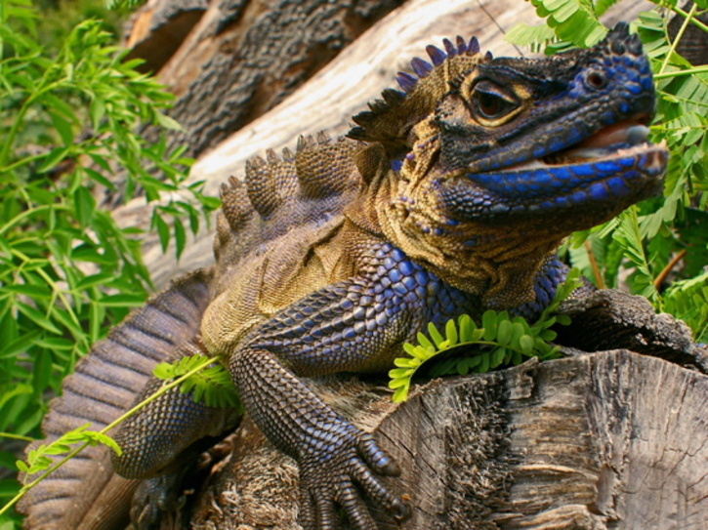

Look how cool this lizard is

Video: youtube.com/watch?v=5DhdbfITsNo&feature=youtu.be

GitHub: https://github.com/charlieM044/SIT210/tree/main/task%208.1

